Name: ________Betzy Morales_____________ A1
Database Systems
NOTES: Keep all numbering intact (-10% if your number is off). Use Shift + Enter a new line without changing the order of the questions.
Part I. Get Ready… (10pts)
- Describe the two approaches to data management shown in Figure 1. What are the benefits and caveats of each? Include at least 3 external reference (MLA or APA citation) and apply your answer using specific CI-related data using your own information as an example. Answers should be around 10 sentences.

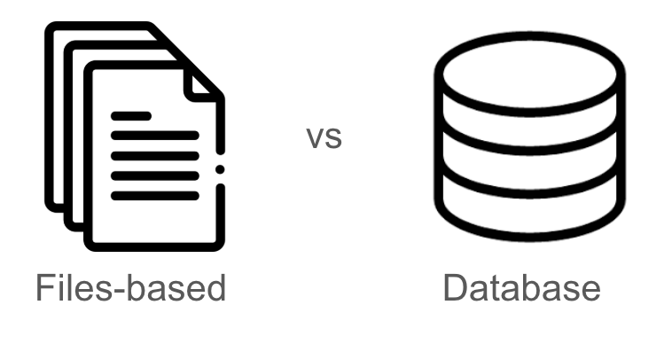
Figure 1. Data Management Approach
Answer:
There are two major approaches to data management shown in Figure , the file-based system and the database system. In the file-based system, the data is stored in separate files which are created by individual applications, this has a down side as this can lead to duplication or inconsistency within the formats (Coronel, C., and Morris, S. (2019) Database Systems: Design, implementation, and Management. Cengage Learning). This system can also lead to difficulty when sharing information across departments. On the other hand a database system, by contrast, it is able to centralize data into a shared structure that is managed by a database management system. This is able to reduce redundancy and improves inconsistency (Harrington, J. L. (2016) Relational Database Design and Implementation. 4th Edition. Morgan Kaufmann). The file-based approach is simple and is able to work well for small, isolated tasks. Although it works well with these tasks it can become inefficient as the dat grows this is due because each file needs to be managed separately. A database management system also known as DBMS is an approach that supports security, multi-user access and structured querying. This makes it more reliable and scalable when it comes to organization (Elmasri, R., and Navathe, S. (2015). Fundamentals of Database Systems, Pearson). For example at CSUCI, my student information, such as my major, courses and financial aid are scattered across several files in a file-based system. This is not ideal for advisors as it would make it more difficult to access accurate information. While on the other hand if they had it in a datable system all the information would be kept and stored in related tables, allowing for quicker access.
Part II. Get Set… (10pts)
Consider converting Figure 2. to a database to answer the questions in Part II.
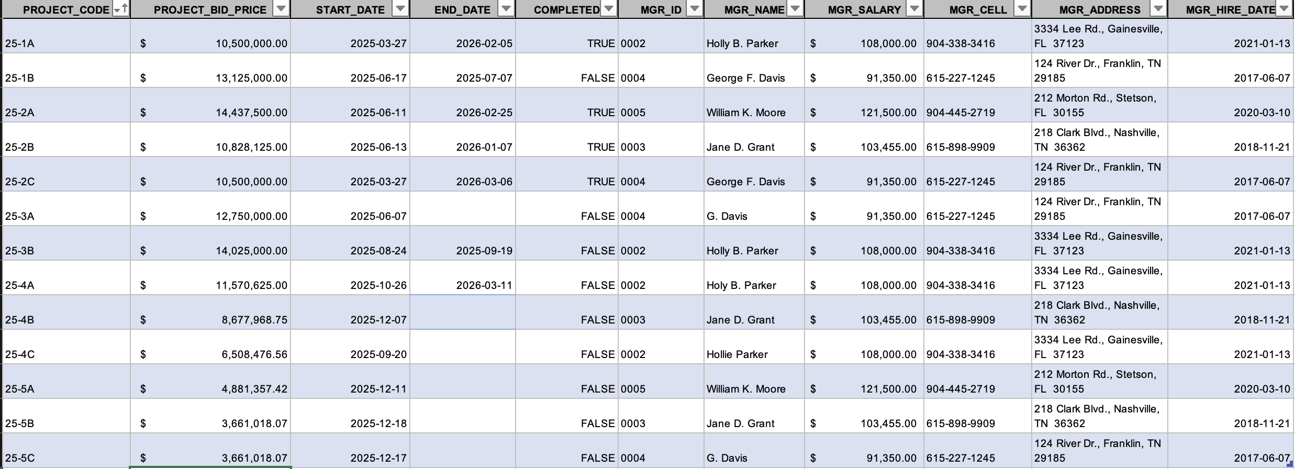
Figure 2 - PROJECT Table
- Identify and describe three different and distinct ‘types’ of metadata a DBA would construct.
  - – Structural metadata - this is able to define tables, fields, data types, and relations.
  - – Descriptive metadata- this is able to explain what each field means
  - – Administrative metadata- this includes access rules, user permissions, update schedules.
- Describe three valid rules, or business rules, that could govern this data.
  - – A project manager that is able to oversee multiple projects at the same time.
  - – each project has a unique project ID
  - – The project cost must be a positive value.
- There are a total of __13___ records with __11___ fields per record.
- The number of duplicate records is __5___.
- The total number of projects assigned to PM George Davis is __2___, totaling $__16,411,018.00___.
- __T___ (T || F) A single manager may work on multiple open projects.
- What problems might you run into should you wish to produce a listing by city? How might you redesign this database to correct for this? Answer: If the city is tired inside the same table as project data it can cause misspellings , inconsistent formatting, redundant city names, and hard to update if a city name changes. A way to redesign is by creating a city table with a cityID and a cityName.

- What data redundancies exist? What might these redundancies lead to? Answer: repeated PM names, repeated city names, repeated department or project types.
- What is a data anomaly? What anomalies exist in this dataset? Answer: a data anomaly is an inconsistency caused by poor database design, especial;;y when data is duplicated.

